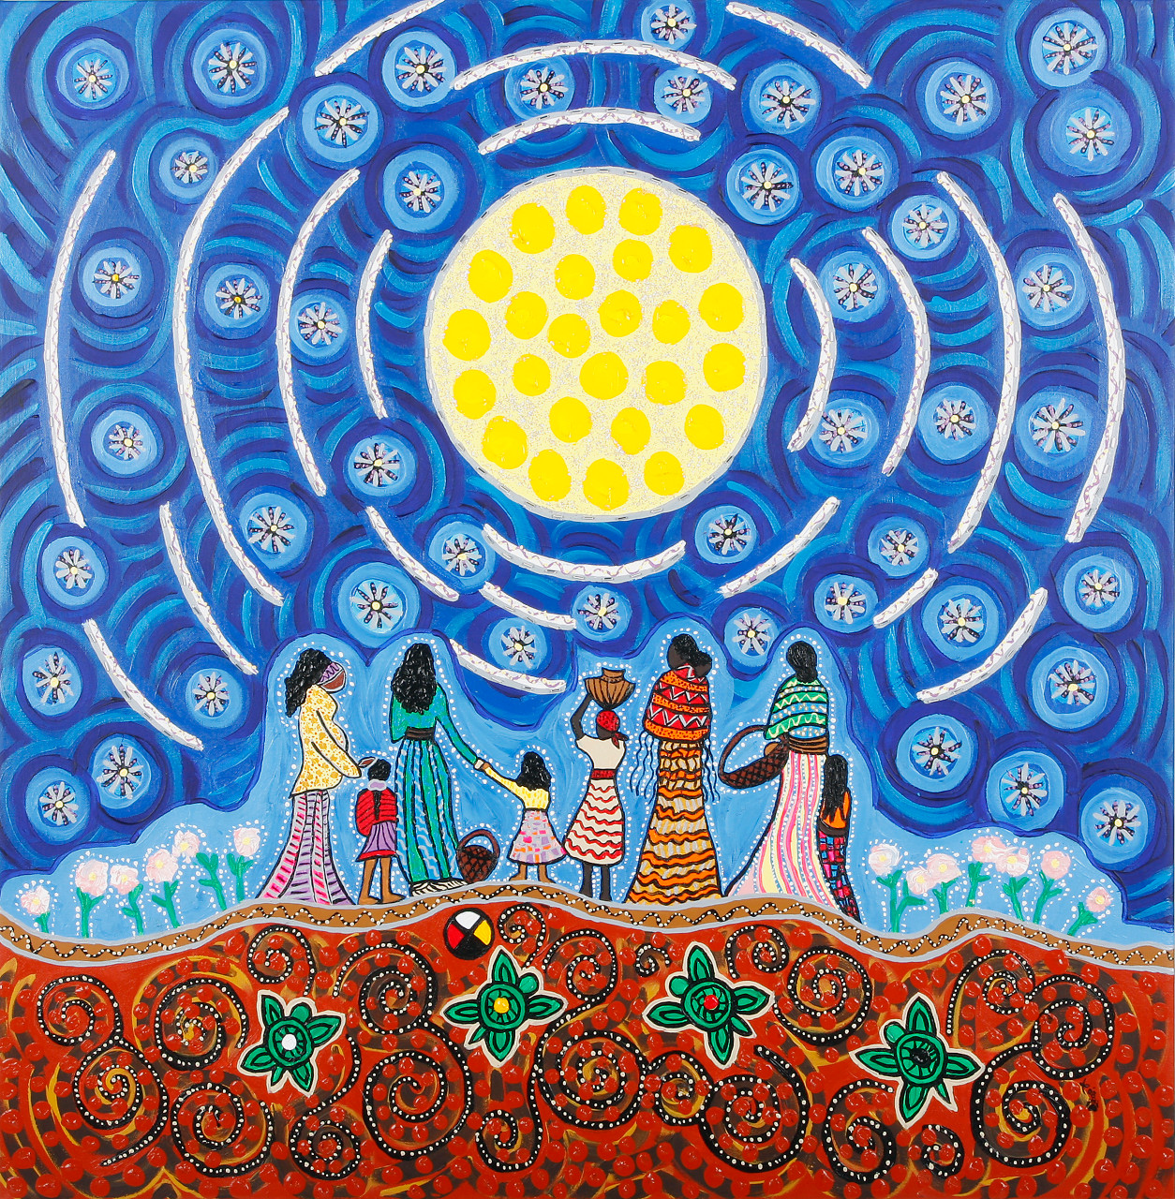

For many cross-­cultural traditions, a ceremony marks a girl's passage to becoming a woman. It is a pivotal time that is an unfolding of trust, innocence, truth, self, and BEAUTY. In today's world, a Girls Rite of Passage is a time for mothers and daughters to celebrate the sacred feminine coming of age that will help a young woman develop her self confidence and understanding of her potential in the world. [WWW.FWFOUNDATION.COM](http://WWW.FWFOUNDATION.COM) (503) 351-8734

WWWW

## Girls Rite of Passage

OCtober 25th & Novemeber 1st

# AT ALMA EDUCATION AND MOVEMENT SPACE

# 1233 SE STARK PORTLAND 97222

✹

# You are warmly invited to

Girls Rite of Passage

A mother-Daughter time to honor a Girl’s Transition to Womanhood

✹